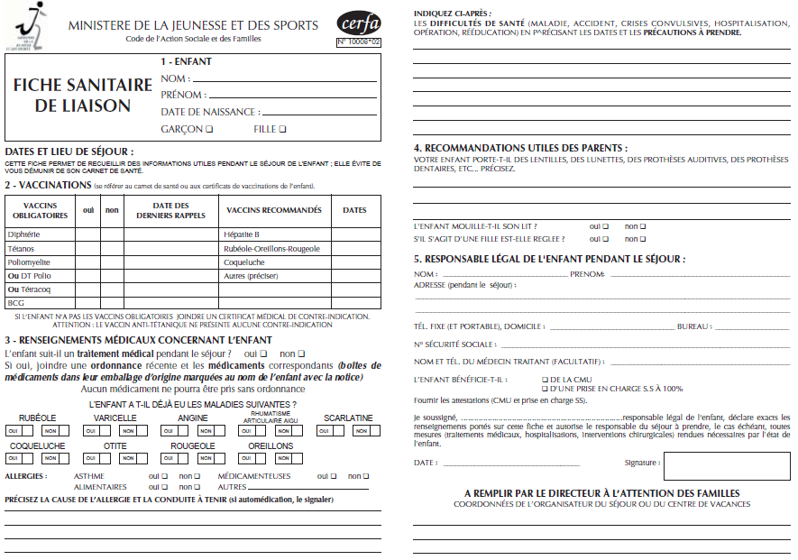

DHUIEGE

06.62.70.40.69

CATHERINE